
Part Number - 51-20988

Installation and Care for Kawasaki Pro MX Soft Door Rear Window Combo

Notice: Do not smoke inside the cab or expose the enclosure to direct flames. Cab is Flammable.

- Be sure to read these instructions thoroughly before opening and installing the Kawasaki Pro MXSoft Door Rear Window Combo. The installation is best done when the temperature is 70 degrees F. or warmer. The temperature affects the adhesive Velcro, if conditions prevent installing in warmer weather it helps to store the adhesive Velcro at room temperature prior to installation.

- Carefully open the carton and remove the enclosure on a large flat surface that is clean and free of dirt.

- Check over the parts included in the carton with the parts list shown below:

Doors - Adhesive Velcro Hook Strips:
Qty Length
18 3 inches
2 4 inches
2 6 inches
2 17 inches
2 32 inches

Rear Window
2 9 inches
2 22 inches
1 25 inches
2 42 inches

Cab Enclosure - 4 panels

The cab will be put together using the following parts and in this order.
1) Doors
2)Rear Window

DOORS

- Begin by installing the doors. If possible, have someone else hold the door in place and mark the location of each Velcro strip sewn along the top and front edges of the door. Now take the supplied 3” adhesive Velcro strips and wrap them around the roll cage at the marked locations. Now put the door back onto the vehicle and wrap the double-sided Velcro around the adhesive Velcro as shown in the photosbelow.

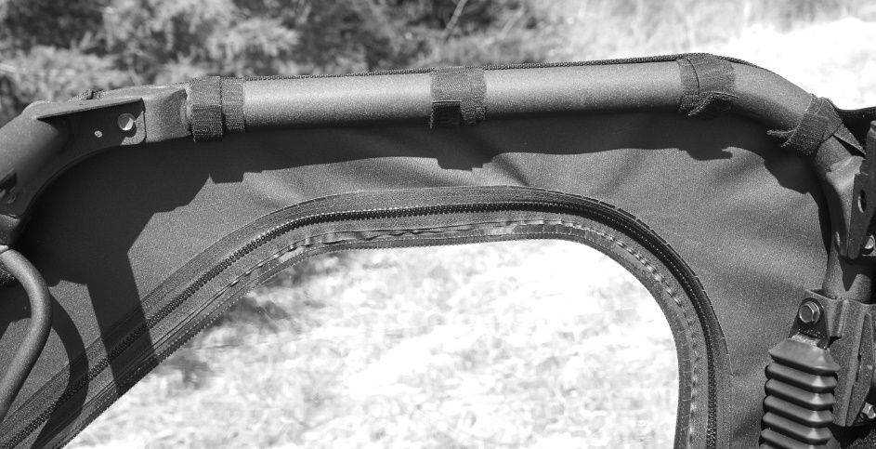

- The rear edge of the doorshas a strip double-sided Velcro tab. Place the 17” adhesive hook strip down the rear of the roll cage. You will need to cut the Velcro so it adheres to each part of the frame.See photos below.

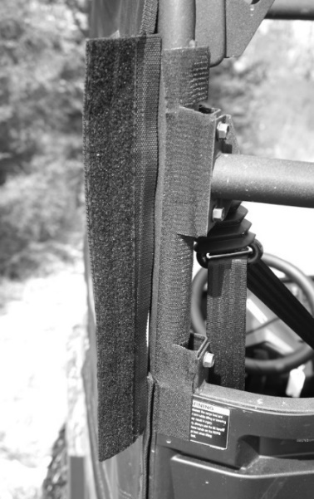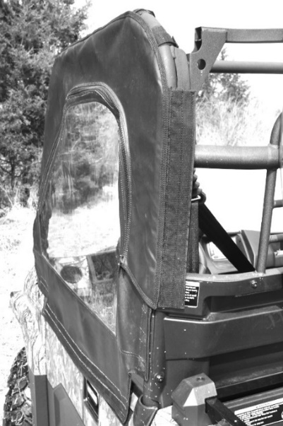

- The diagrams below show how the double-sided straps and the 3” adhesive Velcro works.

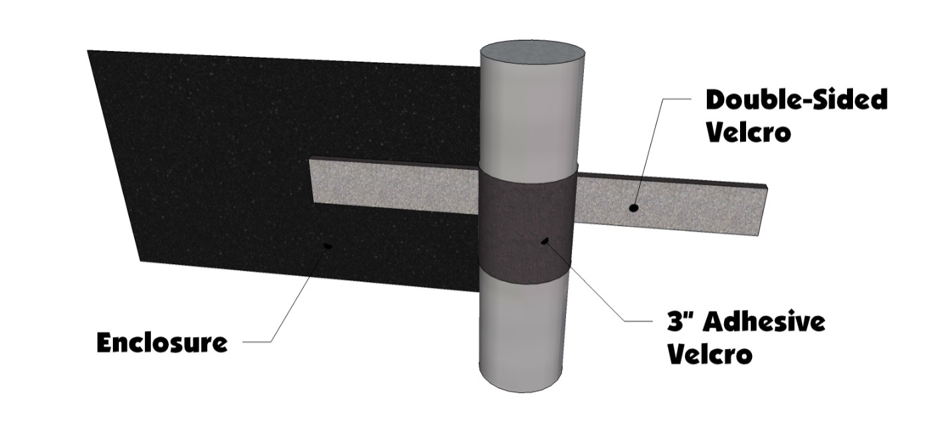

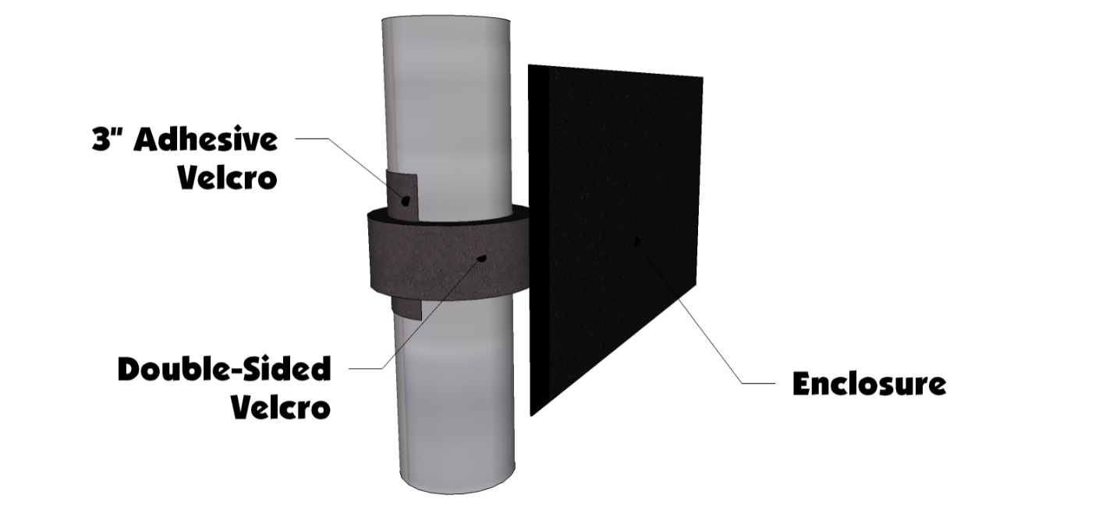

- The bottom corner of the door is held in place by 6” and 32” adhesive Velcro strips. The photo below shows the proper placement.

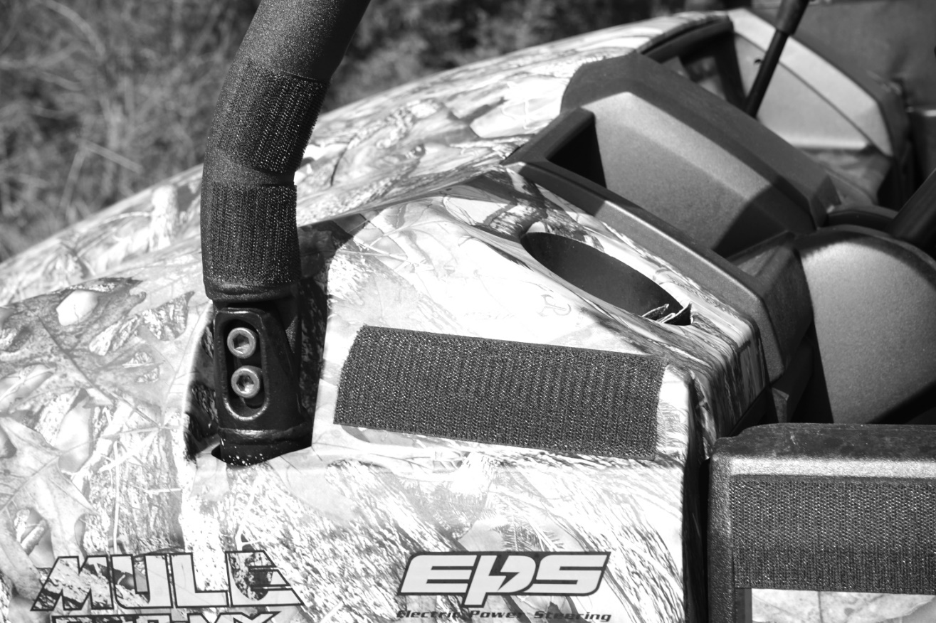

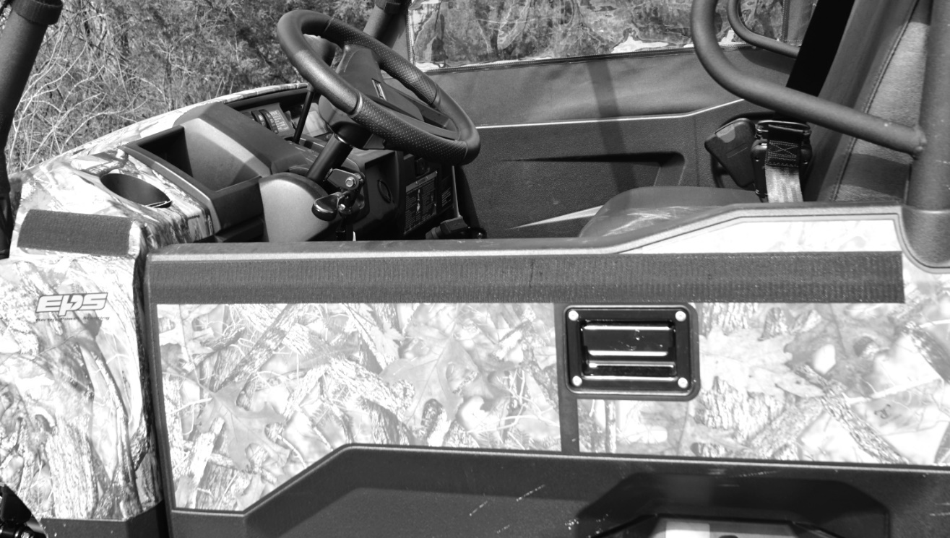

REAR WINDOW

- Begin by placing the 8” and 25" adhesive Velcro strip on top of the top rear bar that runs from one side to the other. The 25” strip goes between the two roof brackets. The photo below shows how this should look.

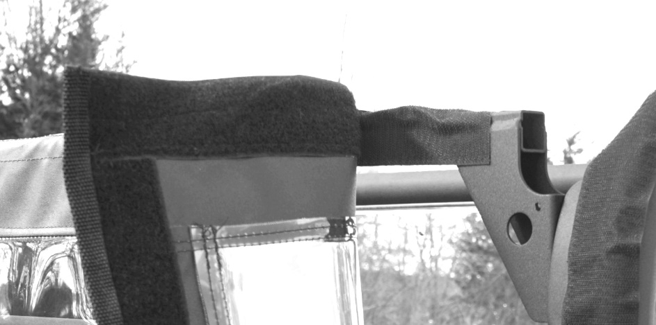
- Next place the two 22" adhesive Velcro strips down the side bars. You will need to cut the Velcro so it adheres to each part of the frame. See photos below.

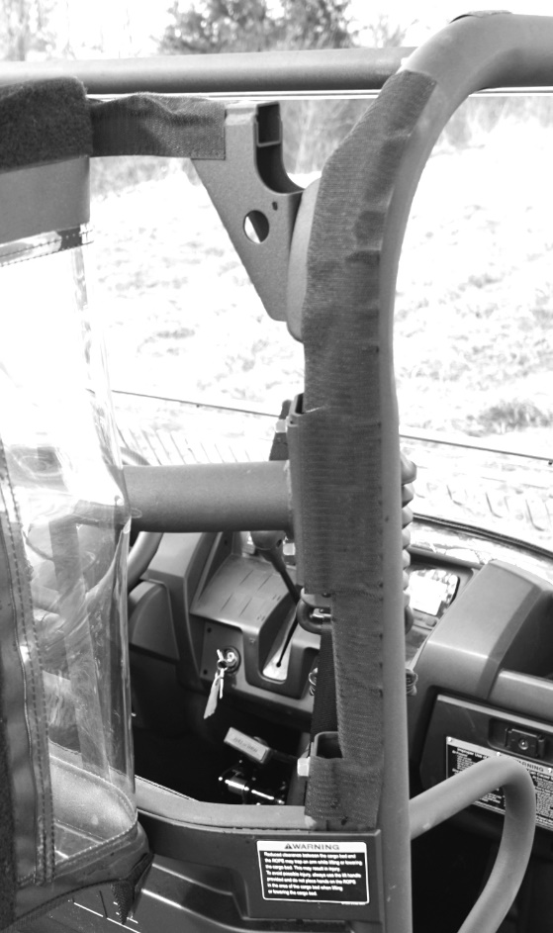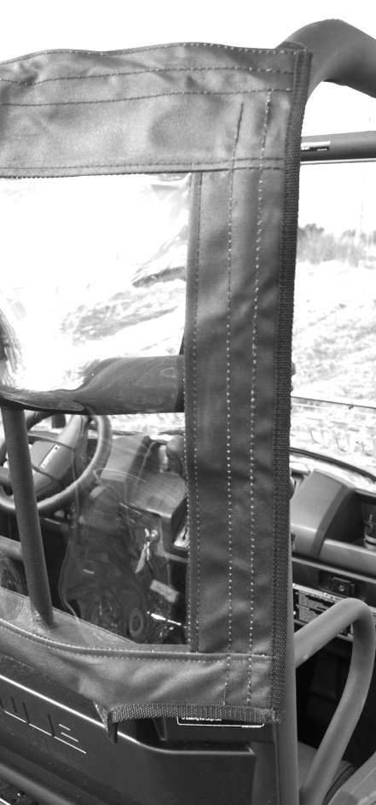

- The bottom of the Rear Window is held in place by the 42" adhesive Velcro strip. The strip goes across the bottom on the plastic from one side to the other. The adhesive strips go on the bottom of the overhang on the plastic. The photos below show what it should look like.
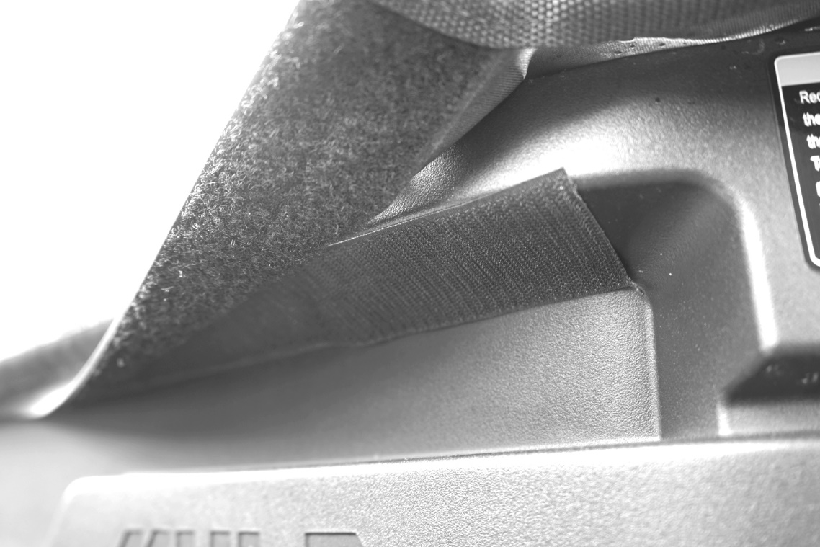

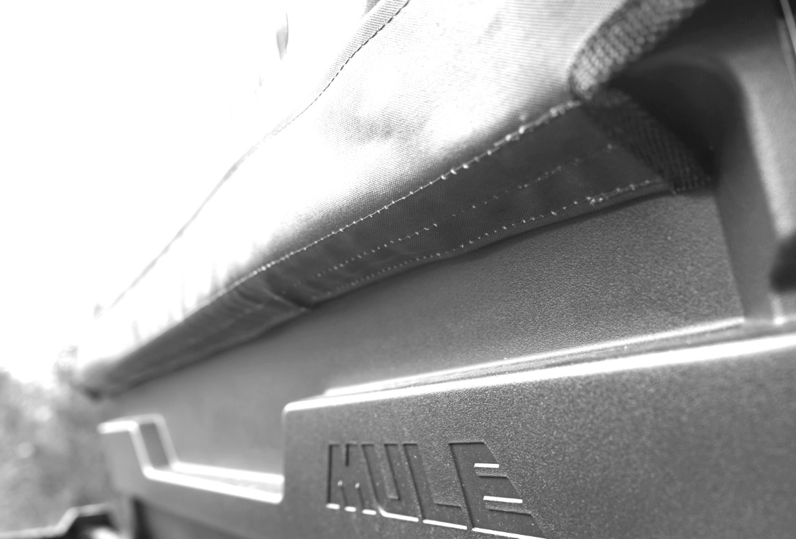

Cleaning and Storage Recommendations:

- Before removing the Over Armour Cab for storage, make sure it is very clean in order to prevent scratching of the window panels. Clean with a soft rag or sponge using a mild liquid detergent soap and warm water solution. Never rub the windows with a dry cloth or rag! Let the Cab dry thoroughly before attempting to roll for storage.

- It is important that the Cab be rolled up for storage rather than folding. Folding will cause damage to the windows!!! Carefully roll up the Cab similar to the way it was when it was packed at the factory. On a large, clean and flat surface, fold the doors over the rear panel first, then, interleave the top and windshield on top of the doors. Begin rolling the Cab into a roll approximately 8 inches in diameter. Put the rolled Cab back into the carton for storage at a normal room temperature. It is best not to expose the Cab to either extreme hot or cold temperatures when storing.

If you have any questions, comments, need assistance, or are missing parts, please contact us by one of the methods below.



WARNING: This product contains a chemical known to the State of California to cause cancer. For more information, go to www.P65Warnings.ca.gov.

