
Part Number - 51-20991

Installation and Care for Can-Am Defender Soft Door Kit

Caution: Do not smoke inside the cab or expose the enclosure to direct flames. Cab is Flammable.

Be sure to read these instructions thoroughly before opening and installing the enclosure. The installation is best done when the temperature is 70 degrees F. or warmer. The temperature affects the adhesive Velcro, if conditions prevent installing in warmer weather it helps to store the adhesive Velcro at room temperature prior to installation.

- Check over the parts included in the carton with the parts list shown below:

2" Adhesive Velcro Strip
4 each 36 inches
2 each 30 inches

Snap Studs - 24 each (2extra)

Door Panels - 2 each

- Begin by cleaning the roll cage and plastic that surrounds the doors. Using rubbing alcohol is preferable. This step is very important for the Velcro strips to properly adhere.

- Now start installation by placing the 2" adhesive Velcro strips around the outside edges of the upper door frame. As you install the adhesive Velcro you will need to pull it into a curve. The result will have wrinkles in it, this is normal, just pull it around as best you can making sure to rub down the Velcro good for maximum adhesion. Starting at the front of the frame first place the 32" strips on the front and top as shown in the following photos.

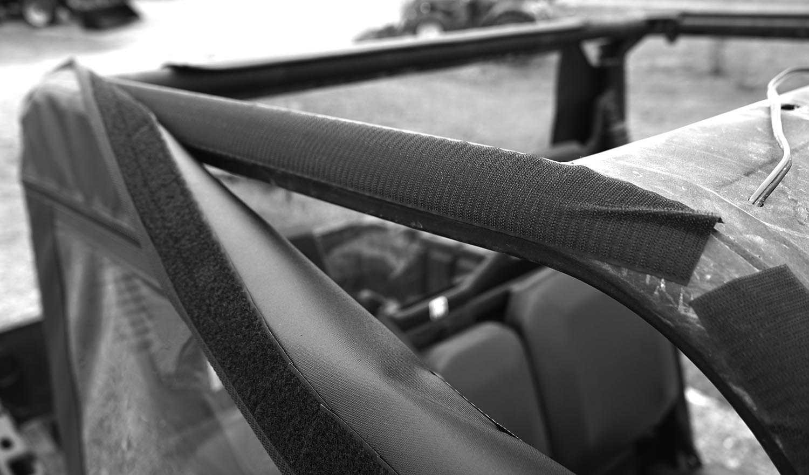
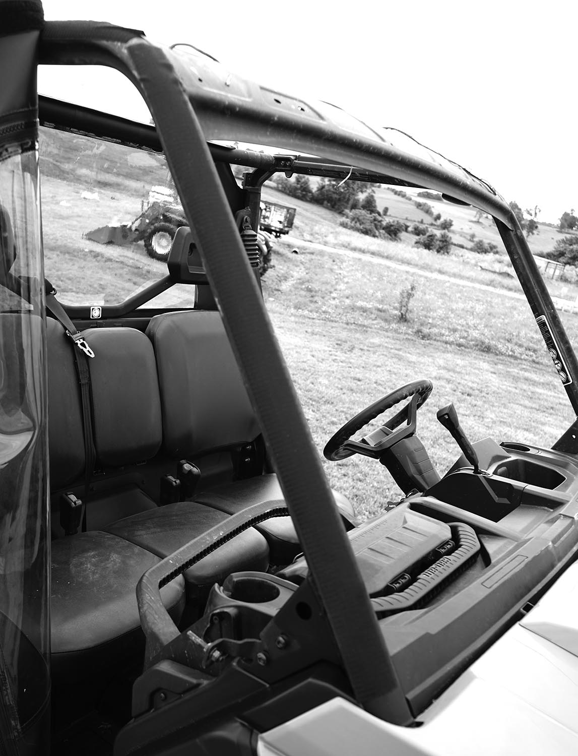

- Next place the 30" strip on the rear vertical bar. See photo below

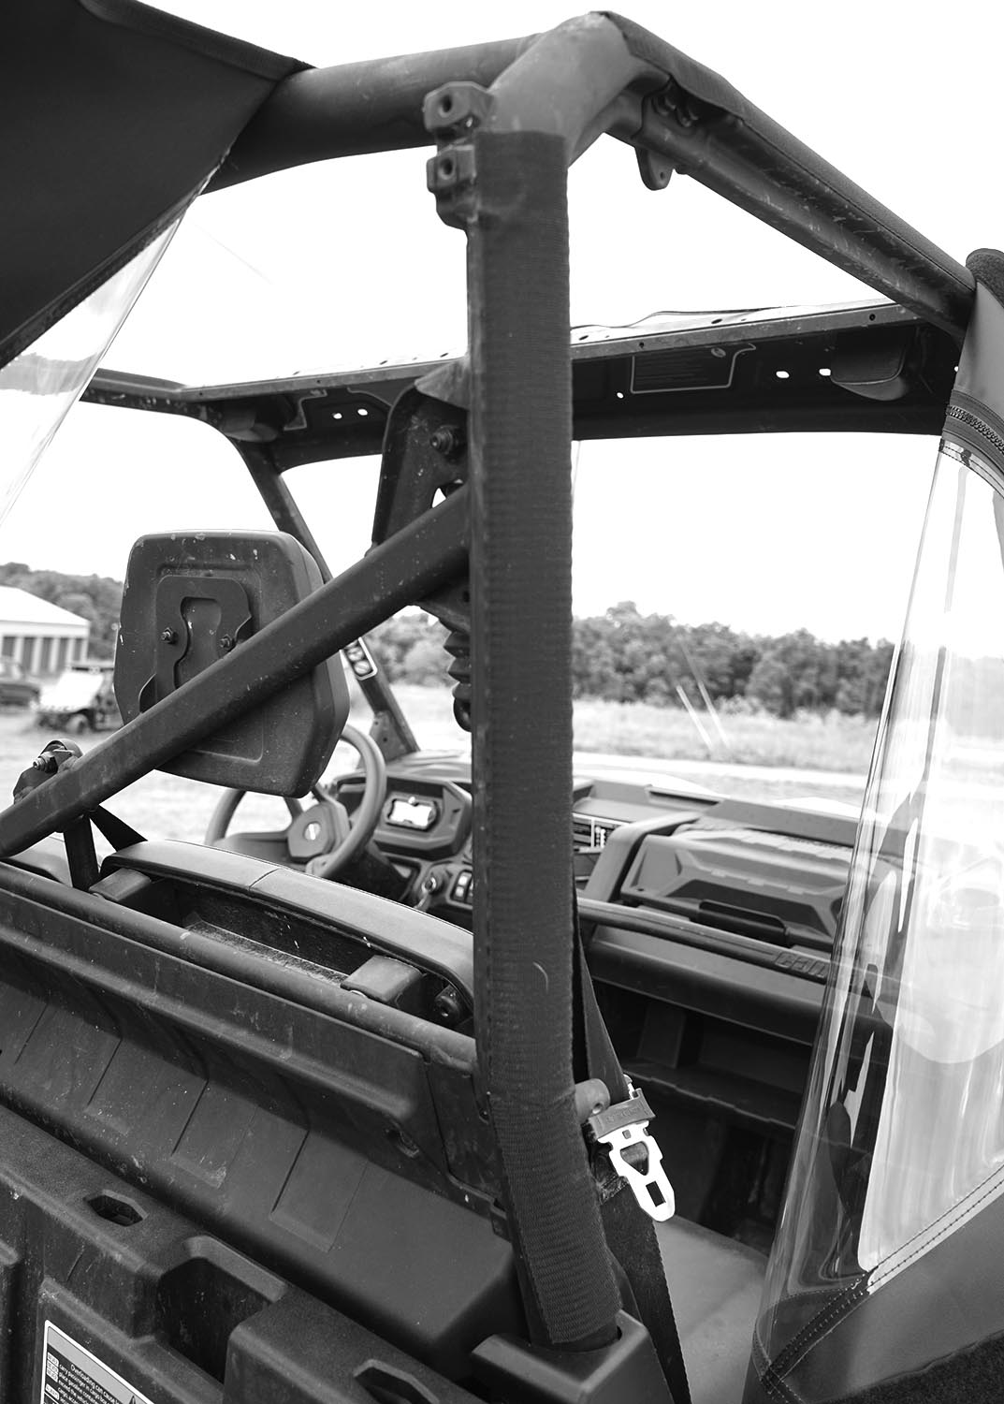

- At this point all you need to do is attach the door to the Velcro along the top and sides. This is done so much easier if you start at the front corner and work your way around the frame.

- Lastly for the doors you will need to attach the screws holding the bottom of the doors. NOTE: It helps to put the snap studs into the sockets in the canvas first. Then one at a time push the screw into the plastic hard enough so that a mark is left behind. Pull the snap stud back out of the door and screw it into the plastic where the mark was made. Snap the door in place and move on to the next one. The snaps along the front of the door wrap around the fenders and will go inside along the fender well. See photos below.

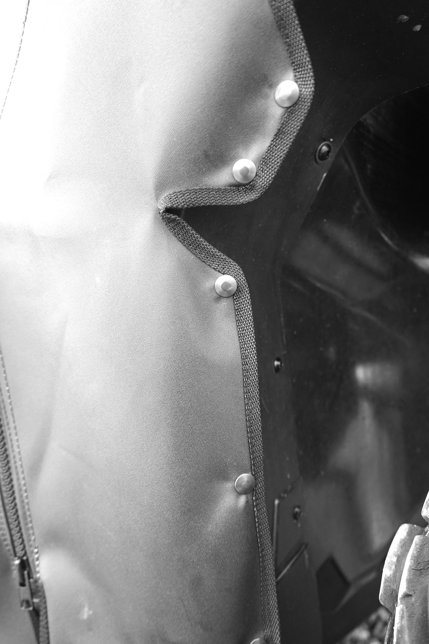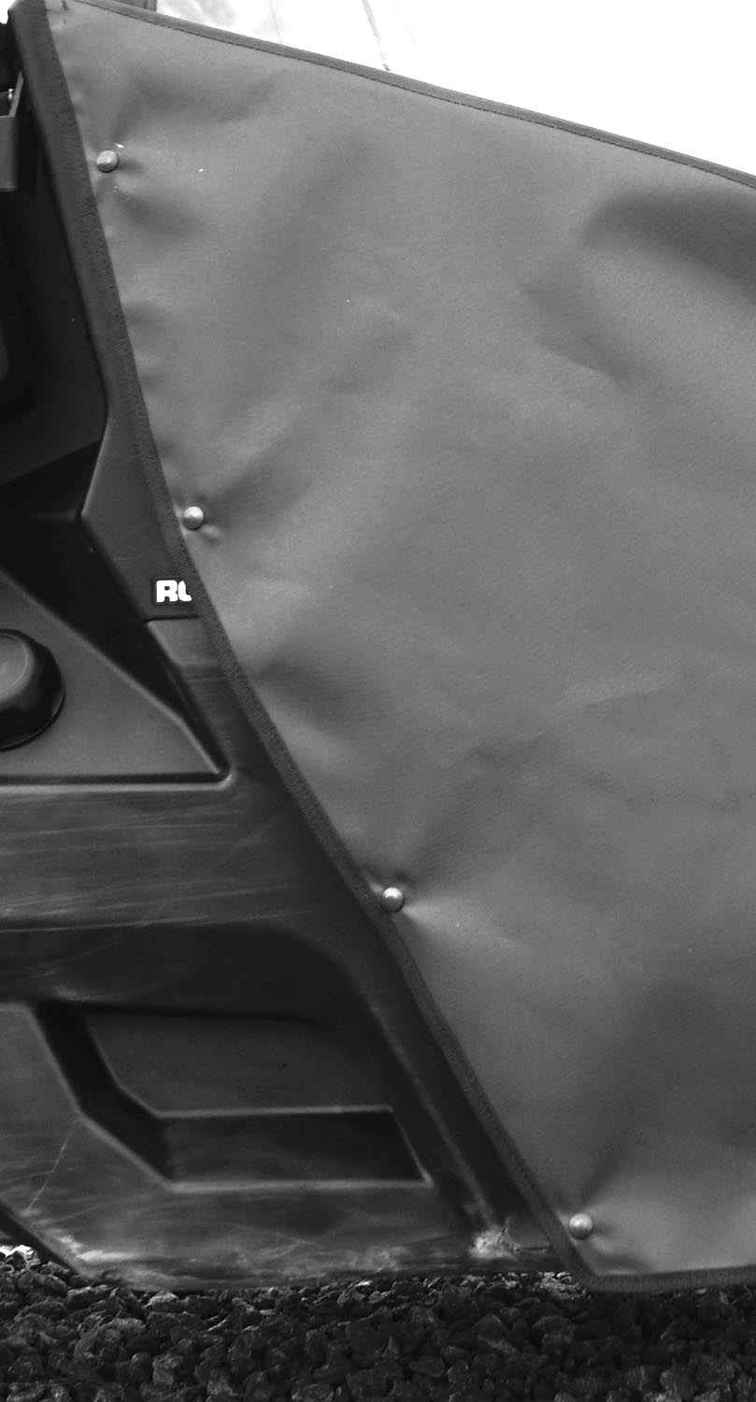

Cleaning and Storage Recommendations:

- Before removing the Cab for storage, make sure it is very clean in order to prevent scratching of the window panels. Clean with a soft rag or sponge using a mild liquid detergent soap and warm water solution. Never rub the windows with a dry cloth or rag! Let the Cab dry thoroughly before attempting to roll for storage.

- It is important that the Cab be rolled up for storage rather than folding. Folding will cause damage to the windows!!! Carefully roll up the Cab similar to the way it was when it was packed at the factory. On a large, clean and flat surface, fold the doors over the rear panel first, then, interleave the top and windshield on top of the doors. Begin rolling the Cab into a roll approximately 8 inches in diameter. Put the rolled Cab back into the carton for storage at a normal room temperature. It is best not to expose the Cab to either extreme hot or cold temperatures when storing.

If you have any questions, comments, need assistance, or are missing parts, please contact us by one of the methods below.




WARNING: This product contains a chemical known to the State of California to cause cancer. For more information, go to www.P65Warnings.ca.gov.

